MEDIVIGAL
Psuedo code:
BEGIN MEDIVIGIL

1. INITIALIZE SYSTEM
Load hospital departments
Load medical resource records
Store Resource ID, Name, Category, Quantity,
Minimum Threshold, Critical Threshold and Priority

2. LOGIN
Display login screen
Read Username and Password

IF Username and Password are valid THEN
Display "Login Successful"
Display Command Center
ELSE
Display "Invalid Login"
STOP
END IF

3. MAIN MENU
REPEAT
Display Main Menu
Display 1. View Resources
Display 2. Add / Update Resource
Display 3. Search Resource
Display 4. Sort Resources
Display 5. Merge / Transfer Resources
Display 6. View Alerts
Display 7. Calculate Readiness
Display 8. Traverse Hospital Hierarchy
Display 9. Save / Export Data
Display 10. Activate Crisis Mode
Display 11. Run Test Suite
Display 12. Exit

Read Choice

4. CHECK RESOURCE STATUS
FOR each resource DO
IF Quantity = 0 THEN
Status ← "OUT OF STOCK"
ELSE IF Quantity <= Critical Threshold THEN
Status ← "CRITICAL"
ELSE IF Quantity <= Minimum Threshold THEN
Status ← "LOW"
ELSE
Status ← "SAFE"
END IF

Calculate Health Score
END FOR

5. SEARCH RESOURCE
Read Search Keyword
Search Resource by ID, Name, Category or Department
Display matching resources

6. SORT RESOURCES
Read Sorting Option

IF Bubble Sort is selected THEN
Apply Bubble Sort
ELSE IF Insertion Sort is selected THEN
Apply Insertion Sort
ELSE
Apply Priority-Based Sorting
END IF

Display sorted resources

7. MERGE / TRANSFER RESOURCES
Read Source Department
Read Target Department
Read Transfer Quantity

IF Source Quantity >= Transfer Quantity THEN
Decrease Source Quantity
Increase Target Quantity
Recalculate Resource Status
Display "Transfer Successful"
ELSE
Display "Insufficient Stock"
END IF

8. CALCULATE READINESS
Count SAFE resources
Count LOW resources
Count CRITICAL resources
Calculate Bed Capacity Score
Calculate Overall Readiness Score

IF Score >= 90 THEN
Display "EXCELLENT"
ELSE IF Score >= 75 THEN
Display "STABLE"
ELSE IF Score >= 50 THEN
Display "AT RISK"
ELSE
Display "CRITICAL"
END IF

9. GENERATE ALERTS
FOR each resource DO
IF Quantity = 0 THEN
Generate "OUT OF STOCK" Alert
ELSE IF Quantity <= Critical Threshold THEN
Generate "CRITICAL" Alert
END IF
END FOR

10. HOSPITAL HIERARCHY TRAVERSAL
Start from Hospital Root
Recursively visit:
Hospital
↓
Department
↓
Category
↓
Resource

Collect resource statistics

11. CRISIS MODE
Activate Crisis Mode
Simulate Emergency Demand
Reduce Critical Resource Quantities
Increase Bed Occupancy
Recalculate Resource Status
Recalculate Readiness Score
Generate Emergency Alerts
Display Crisis Status

12. SAVE / EXPORT DATA
Save updated resource records
Export data to CSV / JSON
Create backup

13. EXIT
Save required data
Display Final System Status
Display "Thank You"
Terminate Program

END MEDIVIGIL

Source code:
#include <stdio.h>
#include <stdlib.h>
#include <string.h>

#define MAX_NAME 50
#define MAX_CATEGORY 30
#define MAX_DEPARTMENT 30

/* ---------- STRUCTURE ---------- */

typedef struct
{
int id;
char name[MAX_NAME];
char category[MAX_CATEGORY];
char department[MAX_DEPARTMENT];

int quantity;
int minThreshold;
int criticalThreshold;
int priority;

char status[20];
int healthScore;

} Resource;

/* ---------- FUNCTION DECLARATIONS ---------- */

void updateStatus(Resource *r);
void viewResources(Resource *r, int n);
void addResource(Resource **r, int *n);
void searchResource(Resource *r, int n);
void sortResources(Resource *r, int n);
void transferResource(Resource *r, int n);
void viewAlerts(Resource *r, int n);
void calculateReadiness(Resource *r, int n);
void traverseHierarchy(Resource *r, int n);
void crisisMode(Resource *r, int n);
void saveData(Resource *r, int n);
void loadData(Resource **r, int *n);
void exportCSV(Resource *r, int n);
void runTestSuite(Resource *r, int n);

void bubbleSort(Resource *r, int n);
void insertionSort(Resource *r, int n);
void prioritySort(Resource *r, int n);

int login();

/* ---------- UPDATE STATUS ---------- */

void updateStatus(Resource *r)
{
if (r->quantity == 0)
{
strcpy(r->status, "OUT OF STOCK");
r->healthScore = 0;
}
else if (r->quantity <= r->criticalThreshold)
{
strcpy(r->status, "CRITICAL");
r->healthScore = 30;
}
else if (r->quantity <= r->minThreshold)
{
strcpy(r->status, "LOW");
r->healthScore = 60;
}
else
{
strcpy(r->status, "SAFE");
r->healthScore = 100;
}
}

/* ---------- LOGIN ---------- */

int login()
{
char username[30];
char password[30];

printf("\n====================================\n");
printf(" MEDIVIGIL LOGIN\n");
printf("====================================\n");

printf("Username: ");
scanf("%29s", username);

printf("Password: ");
scanf("%29s", password);

if (strcmp(username, "admin") == 0 &&
strcmp(password, "1234") == 0)
{
printf("\nLogin Successful!\n");
return 1;
}

printf("\nInvalid Login!\n");
return 0;
}

/* ---------- VIEW RESOURCES ---------- */

void viewResources(Resource *r, int n)
{
int i;

printf("\n================ RESOURCE LIST ================\n");

for (i = 0; i < n; i++)
{
updateStatus(&r[i]);

printf("\nResource ID : %d", r[i].id);
printf("\nResource Name : %s", r[i].name);
printf("\nCategory : %s", r[i].category);
printf("\nDepartment : %s", r[i].department);
printf("\nQuantity : %d", r[i].quantity);
printf("\nMinimum Threshold : %d", r[i].minThreshold);
printf("\nCritical Threshold: %d", r[i].criticalThreshold);
printf("\nPriority : %d", r[i].priority);
printf("\nStatus : %s", r[i].status);
printf("\nHealth Score : %d/100\n", r[i].healthScore);
}
}

/* ---------- ADD RESOURCE ---------- */

void addResource(Resource **r, int *n)
{
Resource *temp;

temp = realloc(*r, (*n + 1) * sizeof(Resource));

if (temp == NULL)
{
printf("\nMemory allocation failed!\n");
return;
}

*r = temp;

printf("\nEnter Resource ID: ");
scanf("%d", &(*r)[*n].id);

printf("Enter Resource Name: ");
scanf(" %49[^\n]", (*r)[*n].name);

printf("Enter Category: ");
scanf(" %29[^\n]", (*r)[*n].category);

printf("Enter Department: ");
scanf(" %29[^\n]", (*r)[*n].department);

printf("Enter Quantity: ");
scanf("%d", &(*r)[*n].quantity);

printf("Enter Minimum Threshold: ");
scanf("%d", &(*r)[*n].minThreshold);

printf("Enter Critical Threshold: ");
scanf("%d", &(*r)[*n].criticalThreshold);

printf("Enter Priority (1-5): ");
scanf("%d", &(*r)[*n].priority);

updateStatus(&(*r)[*n]);

(*n)++;

printf("\nResource added successfully!\n");
}

/* ---------- SEARCH RESOURCE ---------- */

void searchResource(Resource *r, int n)
{
char keyword[50];
int i;
int found = 0;
char idString[20];

printf("\nEnter Resource ID, Name, Category or Department: ");
scanf(" %49[^\n]", keyword);

printf("\n============== SEARCH RESULTS ==============\n");

for (i = 0; i < n; i++)
{
sprintf(idString, "%d", r[i].id);

if (strstr(idString, keyword) != NULL ||
strstr(r[i].name, keyword) != NULL ||
strstr(r[i].category, keyword) != NULL ||
strstr(r[i].department, keyword) != NULL)
{
updateStatus(&r[i]);

printf("\nID: %d", r[i].id);
printf("\nName: %s", r[i].name);
printf("\nCategory: %s", r[i].category);
printf("\nDepartment: %s", r[i].department);
printf("\nQuantity: %d", r[i].quantity);
printf("\nStatus: %s\n", r[i].status);

found = 1;
}
}

if (!found)
printf("\nNo matching resource found.\n");
}

/* ---------- BUBBLE SORT ---------- */

void bubbleSort(Resource *r, int n)
{
int i, j;
Resource temp;

for (i = 0; i < n - 1; i++)
{
for (j = 0; j < n - i - 1; j++)
{
if (r[j].quantity > r[j + 1].quantity)
{
temp = r[j];
r[j] = r[j + 1];
r[j + 1] = temp;
}
}
}

printf("\nResources sorted by Quantity using Bubble Sort.\n");
}

/* ---------- INSERTION SORT ---------- */

void insertionSort(Resource *r, int n)
{
int i, j;
Resource key;

for (i = 1; i < n; i++)
{
key = r[i];
j = i - 1;

while (j >= 0 && r[j].quantity > key.quantity)
{
r[j + 1] = r[j];
j--;
}

r[j + 1] = key;
}

printf("\nResources sorted by Quantity using Insertion Sort.\n");
}

/* ---------- PRIORITY SORT ---------- */

void prioritySort(Resource *r, int n)
{
int i, j;
Resource temp;

for (i = 0; i < n - 1; i++)
{
for (j = i + 1; j < n; j++)
{
if (r[i].priority > r[j].priority)
{
temp = r[i];
r[i] = r[j];
r[j] = temp;
}
}
}

printf("\nResources sorted by Priority.\n");
}

/* ---------- SORT MENU ---------- */

void sortResources(Resource *r, int n)
{
int choice;

printf("\n============== SORT ==============\n");
printf("1. Bubble Sort\n");
printf("2. Insertion Sort\n");
printf("3. Priority Sort\n");

printf("Enter choice: ");
scanf("%d", &choice);

if (choice == 1)
bubbleSort(r, n);

else if (choice == 2)
insertionSort(r, n);

else if (choice == 3)
prioritySort(r, n);

else
printf("\nInvalid choice!\n");

viewResources(r, n);
}

/* ---------- TRANSFER RESOURCE ---------- */

void transferResource(Resource *r, int n)
{
int sourceID;
int targetID;
int quantity;
int source = -1;
int target = -1;
int i;

printf("\n========== RESOURCE TRANSFER ==========\n");

printf("Enter Source Resource ID: ");
scanf("%d", &sourceID);

printf("Enter Target Resource ID: ");
scanf("%d", &targetID);

printf("Enter Quantity to Transfer: ");
scanf("%d", &quantity);

for (i = 0; i < n; i++)
{
if (r[i].id == sourceID)
source = i;

if (r[i].id == targetID)
target = i;
}

if (source == -1 || target == -1)
{
printf("\nResource not found!\n");
return;
}

if (r[source].quantity >= quantity)
{
r[source].quantity -= quantity;
r[target].quantity += quantity;

updateStatus(&r[source]);
updateStatus(&r[target]);

printf("\nTransfer Successful!\n");
printf("%d units transferred.\n", quantity);
}
else
{
printf("\nInsufficient Stock!\n");
}
}

/* ---------- ALERT SYSTEM ---------- */

void viewAlerts(Resource *r, int n)
{
int i;
int alertFound = 0;

printf("\n============== ALERT SYSTEM ==============\n");

for (i = 0; i < n; i++)
{
updateStatus(&r[i]);

if (r[i].quantity == 0)
{
printf("\nOUT OF STOCK ALERT");
printf("\nResource: %s", r[i].name);
printf("\nDepartment: %s\n", r[i].department);
alertFound = 1;
}

else if (r[i].quantity <= r[i].criticalThreshold)
{
printf("\nCRITICAL ALERT");
printf("\nResource: %s", r[i].name);
printf("\nDepartment: %s", r[i].department);
printf("\nQuantity: %d\n", r[i].quantity);
alertFound = 1;
}
}

if (!alertFound)
printf("\nNo critical alerts.\n");
}

/* ---------- READINESS ---------- */

void calculateReadiness(Resource *r, int n)
{
int i;
int safe = 0;
int low = 0;
int critical = 0;
int totalScore = 0;
float readiness;

for (i = 0; i < n; i++)
{
updateStatus(&r[i]);

totalScore += r[i].healthScore;

if (strcmp(r[i].status, "SAFE") == 0)
safe++;

else if (strcmp(r[i].status, "LOW") == 0)
low++;

else
critical++;
}

if (n > 0)
readiness = (float)totalScore / n;
else
readiness = 0;

printf("\n============== READINESS ==============\n");

printf("Safe Resources : %d\n", safe);
printf("Low Resources : %d\n", low);
printf("Critical Resources : %d\n", critical);
printf("Readiness Score : %.2f\n", readiness);

if (readiness >= 90)
printf("Readiness Status : EXCELLENT\n");

else if (readiness >= 75)
printf("Readiness Status : STABLE\n");

else if (readiness >= 50)
printf("Readiness Status : AT RISK\n");

else
printf("Readiness Status : CRITICAL\n");
}

/* ---------- HIERARCHY TRAVERSAL ---------- */

void traverseHierarchy(Resource *r, int n)
{
int i, j;
int departmentExists;

printf("\n========== HOSPITAL HIERARCHY ==========\n");

printf("\nHospital\n");

for (i = 0; i < n; i++)
{
departmentExists = 0;

for (j = 0; j < i; j++)
{
if (strcmp(r[i].department, r[j].department) == 0)
{
departmentExists = 1;
break;
}
}

if (!departmentExists)
{
printf(" |-- Department: %s\n", r[i].department);
printf(" |-- Category: %s\n", r[i].category);
printf(" |-- Resource: %s\n", r[i].name);
}
}

printf("\nHierarchy traversal completed.\n");
}

/* ---------- CRISIS MODE ---------- */

void crisisMode(Resource *r, int n)
{
int i;
int reduction;

printf("\n====================================\n");
printf(" CRISIS MODE\n");
printf("====================================\n");

printf("Emergency demand simulation started.\n");

for (i = 0; i < n; i++)
{
if (r[i].priority <= 2)
{
reduction = r[i].quantity * 30 / 100;

r[i].quantity -= reduction;

if (r[i].quantity < 0)
r[i].quantity = 0;

updateStatus(&r[i]);
}
}

printf("\nCritical resources reduced by emergency demand.\n");
printf("Emergency alerts generated.\n");

calculateReadiness(r, n);
}

/* ---------- SAVE DATA ---------- */

void saveData(Resource *r, int n)
{
FILE *fp;
int i;

fp = fopen("medivigil.dat", "wb");

if (fp == NULL)
{
printf("\nUnable to save data.\n");
return;
}

fwrite(&n, sizeof(int), 1, fp);
fwrite(r, sizeof(Resource), n, fp);

fclose(fp);

printf("\nData saved successfully to medivigil.dat\n");
}

/* ---------- LOAD DATA ---------- */

void loadData(Resource **r, int *n)
{
FILE *fp;

fp = fopen("medivigil.dat", "rb");

if (fp == NULL)
{
printf("\nNo previous data found.\n");
return;
}

fread(n, sizeof(int), 1, fp);

*r = malloc((*n) * sizeof(Resource));

if (*r == NULL)
{
printf("\nMemory allocation failed.\n");
fclose(fp);
return;
}

fread(*r, sizeof(Resource), *n, fp);

fclose(fp);

printf("\nPrevious data loaded successfully.\n");
}

/* ---------- CSV EXPORT ---------- */

void exportCSV(Resource *r, int n)
{
FILE *fp;
int i;

fp = fopen("medivigil.csv", "w");

if (fp == NULL)
{
printf("\nUnable to create CSV file.\n");
return;
}

fprintf(fp,
"ID,Name,Category,Department,Quantity,Minimum,"
"Critical,Priority,Status,HealthScore\n");

for (i = 0; i < n; i++)
{
updateStatus(&r[i]);

fprintf(fp,
"%d,%s,%s,%s,%d,%d,%d,%d,%s,%d\n",
r[i].id,
r[i].name,
r[i].category,
r[i].department,
r[i].quantity,
r[i].minThreshold,
r[i].criticalThreshold,
r[i].priority,
r[i].status,
r[i].healthScore);
}

fclose(fp);

printf("\nData exported successfully to medivigil.csv\n");
}

/* ---------- TEST SUITE ---------- */

void runTestSuite(Resource *r, int n)
{
int passed = 0;
int failed = 0;
Resource test;

printf("\n========== TEST SUITE ==========\n");

/* Test 1 */
test.quantity = 0;
test.criticalThreshold = 5;
test.minThreshold = 10;

updateStatus(&test);

if (strcmp(test.status, "OUT OF STOCK") == 0)
{
printf("Test 1 - Out of Stock : PASSED\n");
passed++;
}
else
{
printf("Test 1 - Out of Stock : FAILED\n");
failed++;
}

/* Test 2 */
test.quantity = 3;

updateStatus(&test);

if (strcmp(test.status, "CRITICAL") == 0)
{
printf("Test 2 - Critical : PASSED\n");
passed++;
}
else
{
printf("Test 2 - Critical : FAILED\n");
failed++;
}

/* Test 3 */
test.quantity = 8;

updateStatus(&test);

if (strcmp(test.status, "LOW") == 0)
{
printf("Test 3 - Low : PASSED\n");
passed++;
}
else
{
printf("Test 3 - Low : FAILED\n");
failed++;
}

/* Test 4 */
test.quantity = 20;

updateStatus(&test);

if (strcmp(test.status, "SAFE") == 0)
{
printf("Test 4 - Safe : PASSED\n");
passed++;
}
else
{
printf("Test 4 - Safe : FAILED\n");
failed++;
}

printf("\nTotal Tests Passed : %d\n", passed);
printf("Total Tests Failed : %d\n", failed);

printf("\nTest suite completed.\n");
}

/* ---------- MAIN ---------- */

int main()
{
Resource *resources;
int n;
int choice;

/* Dynamic memory allocation */

n = 5;

resources = malloc(n * sizeof(Resource));

if (resources == NULL)
{
printf("Memory allocation failed!\n");
return 1;
}

/* Initial Resources */

resources[0].id = 101;
strcpy(resources[0].name, "Oxygen Cylinder");
strcpy(resources[0].category, "Emergency");
strcpy(resources[0].department, "ICU");
resources[0].quantity = 25;
resources[0].minThreshold = 15;
resources[0].criticalThreshold = 5;
resources[0].priority = 1;

resources[1].id = 102;
strcpy(resources[1].name, "Ventilator");
strcpy(resources[1].category, "Equipment");
strcpy(resources[1].department, "ICU");
resources[1].quantity = 8;
resources[1].minThreshold = 5;
resources[1].criticalThreshold = 2;
resources[1].priority = 1;

resources[2].id = 103;
strcpy(resources[2].name, "Blood Unit");
strcpy(resources[2].category, "Blood");
strcpy(resources[2].department, "Blood Bank");
resources[2].quantity = 4;
resources[2].minThreshold = 10;
resources[2].criticalThreshold = 5;
resources[2].priority = 2;

resources[3].id = 104;
strcpy(resources[3].name, "Syringe");
strcpy(resources[3].category, "Consumable");
strcpy(resources[3].department, "Emergency");
resources[3].quantity = 100;
resources[3].minThreshold = 30;
resources[3].criticalThreshold = 10;
resources[3].priority = 3;

resources[4].id = 105;
strcpy(resources[4].name, "Hospital Bed");
strcpy(resources[4].category, "Facility");
strcpy(resources[4].department, "General Ward");
resources[4].quantity = 20;
resources[4].minThreshold = 10;
resources[4].criticalThreshold = 3;
resources[4].priority = 4;

/* Update initial status */

for (int i = 0; i < n; i++)
{
updateStatus(&resources[i]);
}

/* Login */

if (!login())
{
free(resources);
return 0;
}

/* Main Menu */

do
{
printf("\n\n============================================\n");
printf(" MEDIVIGIL\n");
printf(" HOSPITAL RESOURCE COMMAND CENTER\n");
printf("============================================\n");

printf("\n1. View Resources");
printf("\n2. Add Resource");
printf("\n3. Search Resource");
printf("\n4. Sort Resources");
printf("\n5. Merge / Transfer Resources");
printf("\n6. View Alerts");
printf("\n7. Calculate Readiness");
printf("\n8. Traverse Hospital Hierarchy");
printf("\n9. Save / Export Data");
printf("\n10. Activate Crisis Mode");
printf("\n11. Run Test Suite");
printf("\n12. Exit");

printf("\n\nEnter your choice: ");
scanf("%d", &choice);

switch (choice)
{
case 1:
viewResources(resources, n);
break;

case 2:
addResource(&resources, &n);
break;

case 3:
searchResource(resources, n);
break;

case 4:
sortResources(resources, n);
break;

case 5:
transferResource(resources, n);
break;

case 6:
viewAlerts(resources, n);
break;

case 7:
calculateReadiness(resources, n);
break;

case 8:
traverseHierarchy(resources, n);
break;

case 9:
saveData(resources, n);
exportCSV(resources, n);
break;

case 10:
crisisMode(resources, n);
break;

case 11:
runTestSuite(resources, n);
break;

case 12:
saveData(resources, n);

printf("\n====================================\n");
printf(" FINAL SYSTEM STATUS\n");
printf("====================================\n");

calculateReadiness(resources, n);

printf("\nThank you for using MEDIVIGIL!\n");
break;

default:
printf("\nInvalid choice! Please try again.\n");
}

} while (choice != 12);

/* Free dynamically allocated memory */

free(resources);

return 0;
}

TEST CASES
OVERALL OUTPUT DASHBOARB
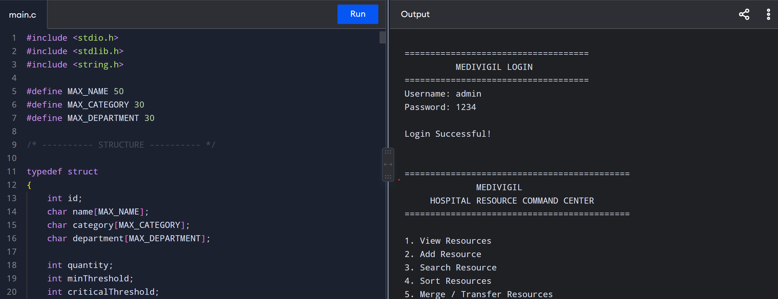
1
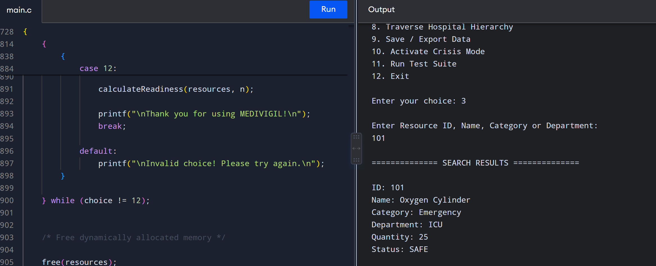
2
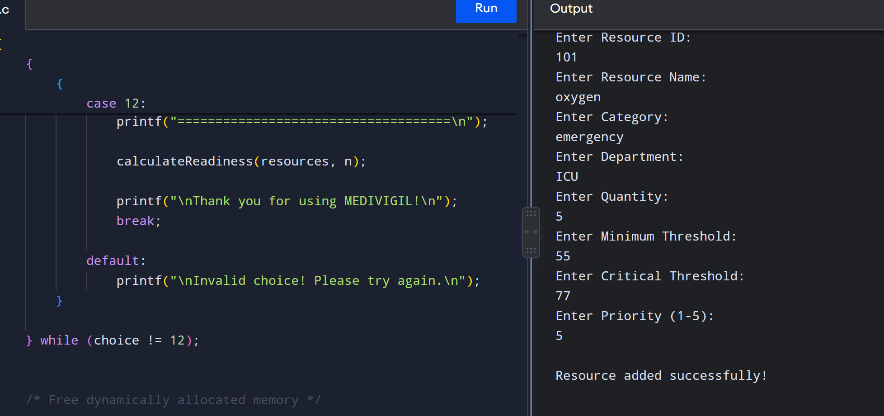
3
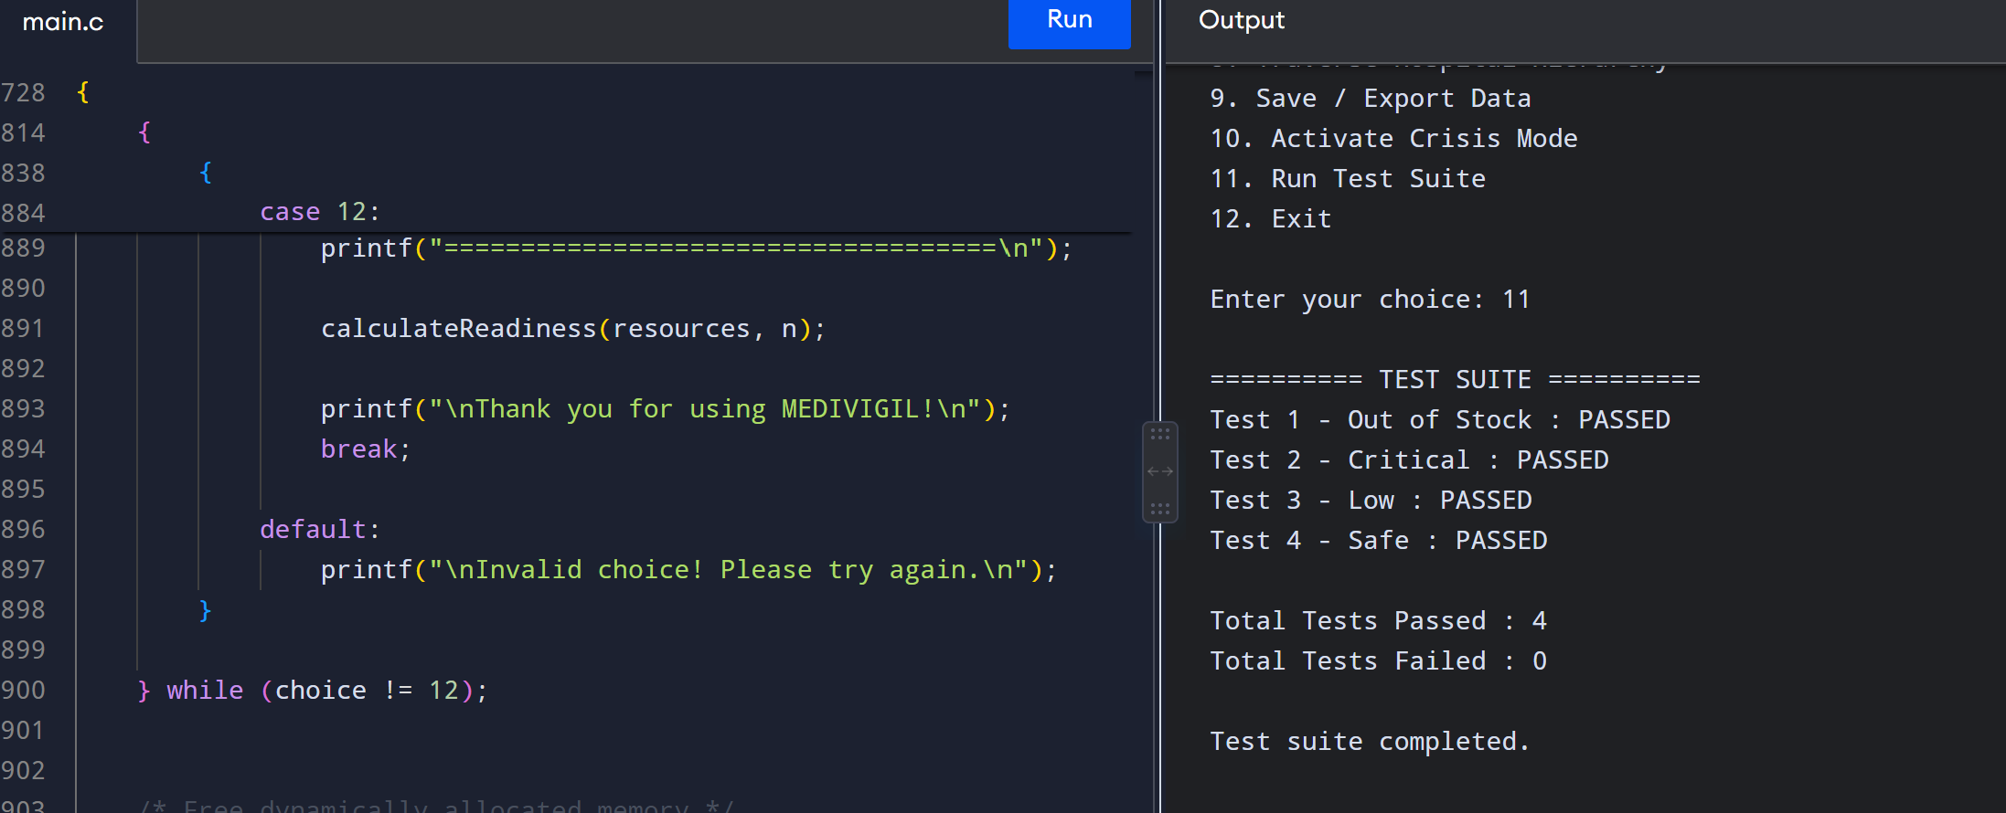
4
